

AUTHORIZATION FOR DIRECT DEPOSIT (ACH Credit)

I/we hereby authorize Big Sandy Rancheria, (“Company”) to electronically credit my/our account (and if necessary, to electronically debit my/our account to correct erroneous credits) at the financial institution named below. I/we agree that ACH transactions I/we authorize comply with all applicable law.

Bank Name __________________________________________________________________________

Routing Number _____________________________

Account Number _____________________________ Checking Account Savings Account

Name(s) on Account ___________________________________________________________________

I/we understand that this authorization will remain in full force and effect until I/we notify Company in writing or by phone at the location address on file at least 30 days prior to the proposed effective date of the termination of authorization.

Signature ___________________________________________ Date ____________________________

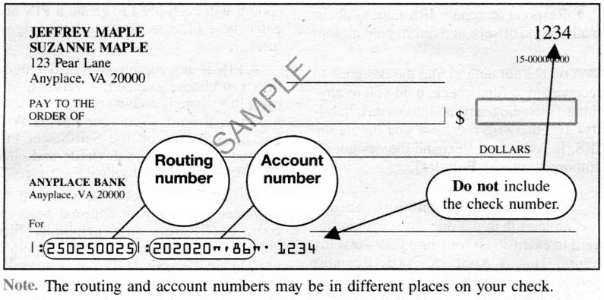
Please attach a VOIDED CHECK to this authorization if a checking account will be credited.

